The questions:

* How many conference calls did we download in total for all years?

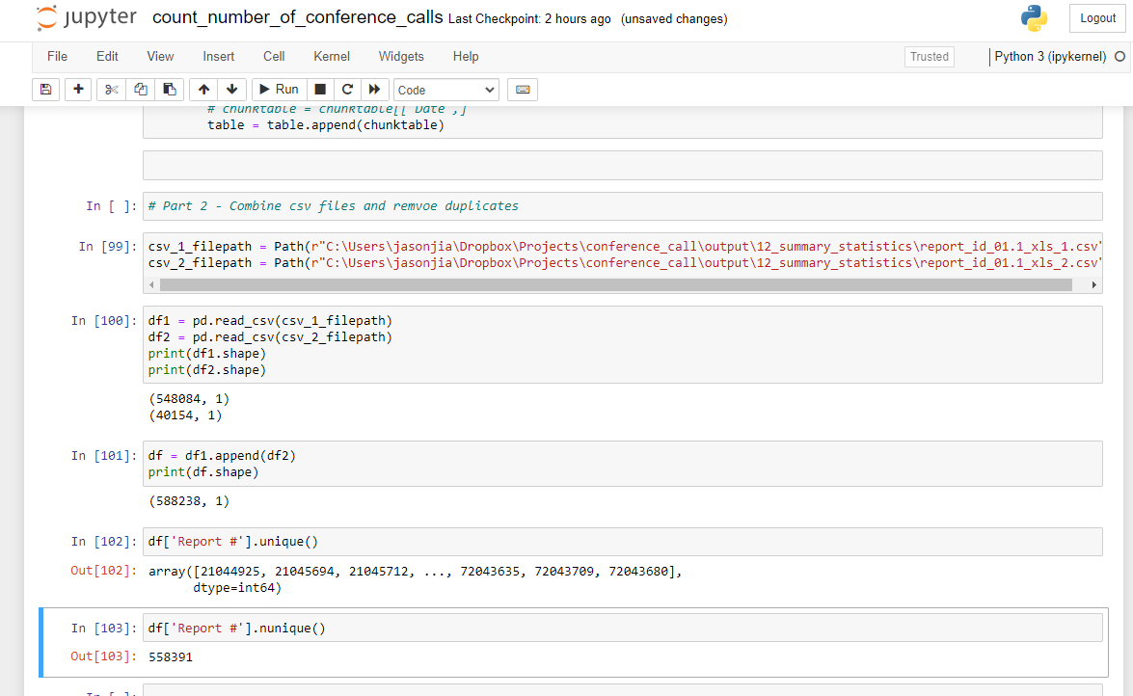

Compile all the .xls files and remove report IDs that are duplcaes

Number of pdf files: 11852 + 843 pdfs.

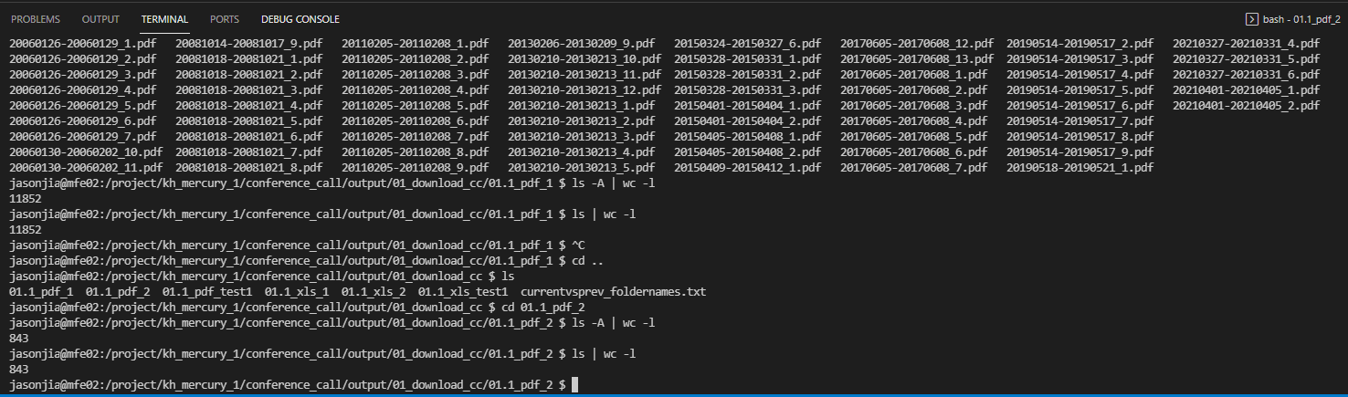

How many conference calls have at least one relevant keyword?

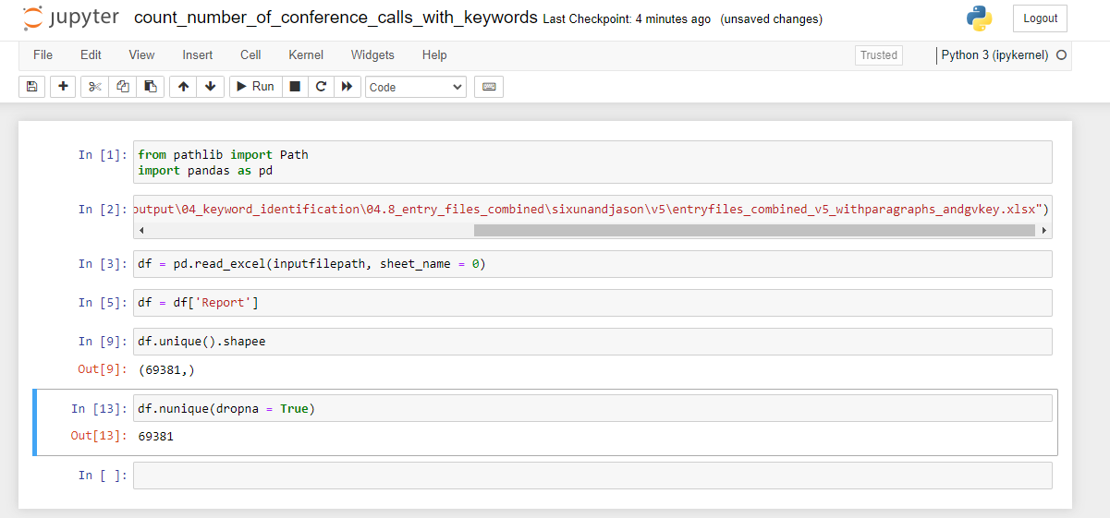

69381